|  |
| --- |
| Johns Hopkins University School of Medicine  Institute for Clinical and Translational Research  Center for Clinical Data Analysis  CCDA-XXXX  Data Guidance |
| [Study PI(s), [Study Title] |



|  |
| --- |
| [author name and date] |

# About this document

Thank you for using the Center for Clinical Data Analysis to meet your data research needs. This document was prepared to explain details and caveats regarding the data delivered to you. If you have further questions about your data, please contact Maithilee Mitra for follow-up.

# About your data

## Delivered to a secure location

Your data has been placed on the SAFE virtual desktop, which is approved for delivery of PHI

To meet your responsibility for the security of this data, you should consider this location for your work. If space constraints or other concerns cause you to considering moving this data to do your analysis, you are responsible for doing so in compliance with the Use Of Data Agreement you signed, and policies of Johns Hopkins Medicine. CCDA is available to help you evaluate your needs and put you in touch with enterprise resources to ensure the security of your research data.

## File Format

Your data was exported in pipe-delimited format (.txt) instead of Excel (.xslx) due to the limitations of Excel with large data sets. To open the files in Excel, follow the steps below:

1. Select Delimited from the original file type, and select the “My data has headers” option button. Click Next to continue.

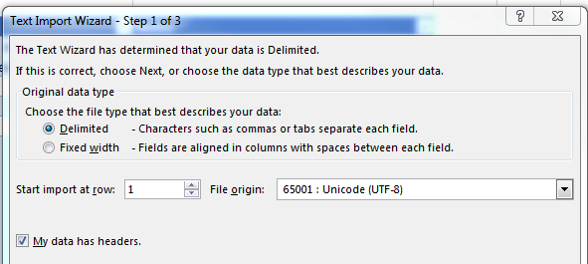

1. Select the “Tab” and “Other” option buttons, and type the pipe (|) in the text area next to “Other”. (Pipe is the shift character above the Enter key.) Click Next to continue.

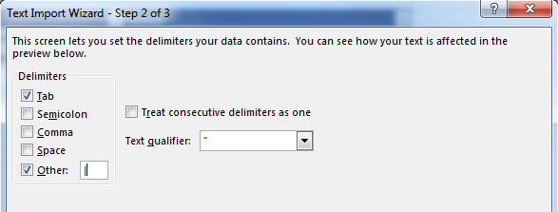

1. You can preview your data by clicking the Finish button.

## Data Extract Files

### Extract File #1

|  |  |
| --- | --- |
| **Data Element** | **Description** |
| Column 1  (Primary Key) | Information about column 1 (including whether or not is serves as a key for other files) |
| Column 2 | Description of column 2 |
| Column 3 | Description of column 3 |
| .… |  |
| …. |  |

### Extract File #2

In-person outpatient office visits to during specified time range.

|  |  |
| --- | --- |
| **Data Element** | **Notes** |
| Column 1  (Primary Key) | Information about column 1 (including whether or not is serves as a key for other files) |
| Column 2 | Description of column 2 |
| Column 3 | Description of column 3 |
| .… |  |